DEFECT REPORT

Defect Details:
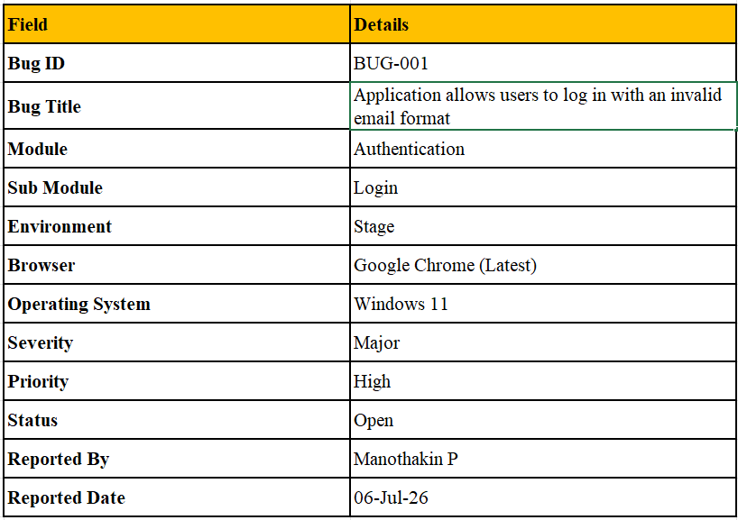
Defect Summary:
The Login module accepts an invalid email format and allows the login request to proceed without displaying an appropriate email validation message. This behaviour violates the expected input validation requirements.

Preconditions:
- User is on the Login page.
- Application is accessible.
- Internet connection is available.
Test Data(Invalid email format):
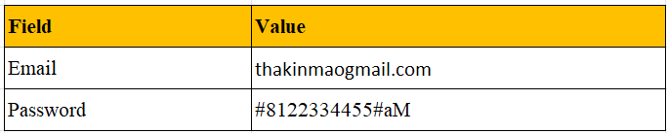
Steps to Reproduce:
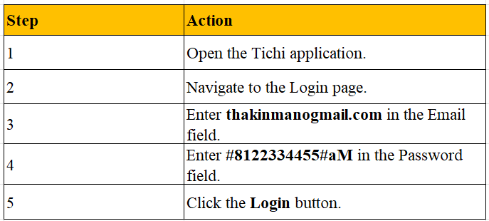
Actual Result:
The application accepts an invalid email format (e.g., abcgmail.com) and processes the login request without displaying any email format validation message.

Expected Result:
The application should validate the email format before processing the login request. If an invalid email address is entered, an appropriate validation message should be displayed, and the login request should not be processed until a valid email address is provided.
Business Impact:
- Invalid data reaches the authentication process.
- Unnecessary login requests increase server load.
- Poor user experience due to missing client-side validation.
- Indicates incomplete input validation in the Login module.
- May increase the risk of invalid authentication requests reaching the backend system.
Recommendation:
Implement both client-side and server-side email format validation to ensure that only valid email addresses are accepted. The application should prevent the login request from being submitted until the entered email address meets the required format.
Observation:
During testing, it was observed that the Login module accepted an invalid email format and allowed the login request to proceed without displaying an appropriate validation message. This indicates that the email validation mechanism is either missing or not functioning correctly.

